Title: Fontwala: Stone to mobile, what remains?
2019, Adobe and Coral Draw;
by Rajeev Prakash Khare & Shubhra Prakash
A show that surveys the development of Devnagri letterform from it’s earliest stone engravings to its digital adaptations.
For immediate release:
Kaleidoscope Digital Art – KDA and curator Mukta Ahluwalia present an informative digital art show Fontwala: Stone to mobile, what remains?
It explores the journey of the Indian letterform, specifically through Devnagri script. The show investigates what is lost and what remains from times when legacies were written in stone and metal to now, when the letterform of the Indian languages have found a presence on various technical mediums. Indian letterforms were labeled as “complex” scripts until the arrival of Unicode that enabled their development in digital mode. Through Khare’s perspective and experience as a typeface designer and calligrapher, the exhibit reflects on the pioneers who maintained the aesthetics of the letterform, the challenges experienced in transition from one medium to another; and the possibilities that lie ahead for the letterform and a call for technical adjustments to accommodate the legacy of notable Indian scripts. As the creative producer, Shubra Prakash, distills the vast content of typeface history and Khare’s commitment towards it.
The exhibition will be held at:

Kaleidoscope Digital Art is
from 27 July to 17 August 2019
10:30 a.m. to 6:30 p.m. (Sundays closed)
at KDA, Triveni Kala Sangam
205, Tansen Marg, Mandi House,
New Delhi 110001.

Introduction to Fontwala: Stone to mobile, what remains?
The seven videos present the development of Devnagri from Brahimi and it’s evolving mediums – stone pillars to digital screens. Prakash and Khare unravel the embryonic interconnection of all akshars and the inherent beauty of the script with its maatras and other accents.

The show brings forth Khare’s commitment to preserving the Indian typeface against the background of changing world order and a rapidly evolving digital era. He builds his practice on the earlier work of typeface pioneers to preserve the integrity of the Indian script as technology changed from printing press to digitization for computers to mobile screens. What readers take for granted as an easy transformation was, and still is fraught with challenges of technology as well as easy readability. The size of the font or typeface design itself impacts how it is received on various platforms. Khare focused his practice and artistic responsibility on preserving the graceful beauty and rich cultural heritage that is encapsulated within the script and language. Language is the carrier of cultural systems. Script is mode of communication it to a wider population. Loss of language results in the eventual loss of culture. It has been observed historically that the substitution of local scripts with a politically dominant script led to eventual corrosion of script, language and eventually the indigenous culture. In recent colonial history, complex Asian scripts were substituted by easily available Roman script for the convenience of transferring into new mediums.
Khare, who has been fascinated with akshar since childhood, has artistically and technically explored all mediums – be it painted wall advertisements or software design for industrial applications. His love for the Devnagri font manifests as akshars that float in front of his eyes as visions. He converts these aesthetic visions in to a typeface that is accessible to the reader, while staying true to is integral identity. He says, “the work is not fulfilled till it is received and understood by the reader.”

The curator Mukta Ahluwalia says “I truly believe in the power of contemporary art and new technologies to bring about positive social change. Through Fontwala, the audience gets a glimpse in the continuity between Devnagri and Brahimi scripts. One also gets to see the perhaps otherwise overlooked ornamental beauty of the script as explained by Khare. One takes digitization of the age-old script for granted. The show offers a pause into challenges and dedication of Khare and other typeface pioneers.”

Bobby Bedi, the founder of KDA says, “Digital lets you experience art with all your senses. Moreover, Digital Art can be created and shared in the original by millions. KDA is committed to ensuring that artists, young and old, get an opportunity to share their digital vision.”

About the Artists

Rajeev Prakash Khare
Rajeev Prakash Khare has been trained as a calligrapher and typographer under the renowned calligrapher and father of today’s digital Indian language typography Prof. R.K. Joshi and Mr. Gopal Bhai Modi, founder of Gujarat Type Foundry, Mumbai. In the 1990s Rajeev founded VSOFT a type design software company and worked with significant institutions including the Indian Government.
In 1980 he designed calligraphic headlines in Manohar Kahaniyan and Manorama magazine. During his fine arts study period at Banaras Hindu University, he worked as calligrapher and lettering artist in many advertising agencies. He completed his masters at IDC IIT Mumbai where his areas of study included advance typography and type design. While at IDC IIT he designed his first Hindi font for Dot Matrix Printer. This project was done under Dr. P K Mudur of NCST Mumbai and R K Joshi. He went on to design IDC Rajeev Normal Hindi font for laser printer. His focus was to develop a mono thickness Hindi font similar to Helvetica for bilingual text processing. This font went on to be used for corporate identity of Postal department of Government of India in 1989-90. While still at his masters he developed, the entire family, Normal Italic, Bold and Bold Italic fonts of IDC Rajeev.
Khare as always wanted to realize all possible roles I could within the typeface universe, whether it was as a type designer, type calligrapher, type entrepreneur or type user. Having spent 33 years in typography, he has experienced various phases of evolution of typography in India. Rajeev remains curious and excited about handwritten calligraphy, hot-metal hand composing as well as today’s high-resolution display devices. A true visual artist at heart he has designed and created artwork and design for several publications, books, literary festivals, etc. He is a strong advocate of technical adjustments and advancements needed to accommodate Indian scripts and letterforms that make up languages of a billion people. He plans to continue employing his expertise in Indian language typography to explore new opportunities within typeface development in the global community.

Shubhra Prakash
Shubhra Prakash is a theatre artist who most recently co-wrote produced and acted in an original play The Music In My Blood about Indian classical music that was seen by over a thousand audience members in the New York City area and the east coast. Shubhra was the voiceover artist for Priya’s Shakti, a multi-platform project supported by Tribeca New Media fund which has garnered over 400 press and media mentions. She has co-founded the award-winning NYC based Hypokrit Theatre Company. She served as festival director of company’s South Asian International Performing Arts Festival in its inaugural year 2015. Recently relocated to India to develop her next play Fontwala that is inspired by the life of Rajeev Prakash Khare who is also her uncle and the reason she learned about art at an early age. Along with being a theatre maker she works with video production and has scripted, filmed, edited and animated content for the current exhibition.

About KDA
Kaleidoscope Digital Art - KDA - is founded by Varsha and Bobby Bedi. It is an experimental platform for artists pushing the boundaries of their practice by engaging with constantly evolving technologies for creation and presentation of their work. This includes digital photography, videos, films, sound and animation. It will also present digital documentation and presentation of time-based art forms. KDA is a not-for-profit organization offering rent-free display space to artists, thereby facilitating viewership for digital art forms. Under the artistic direction of Mukta Ahluwalia, the focus is to build a vibrant creative community of artists and audiences exploring the untapped potential of technology in art making. KDA will also host artist talks, discussions and other programs to enable deeper engagement with the creative community and audiences. KDA hopes to eventually provide programs that inform, educate and enable artistic development. For more information contact: kdaenquries@gmail.com

Interviews:

The artists Rajeev Praksah Khare and Shubra Praksh and curator are available for interviews. Please email us for high-resolution images. Images in this document are for reference only.

Contact:

PR Team at Kaleidoscope Digital Art KDA
Email: kdaenquries@gmail.com.

Mb: +919999651085

Artists: Rajeev Prakash Khare and Shubra Prakash

Emails: rajeevfontwala@gmail.com; prakashnitza@gmail.com

Mb: +91 9599967044

Low res-images in this document for reference only. All images copyrighted to the artists and courtesy artists.

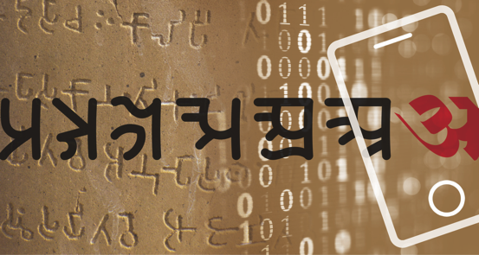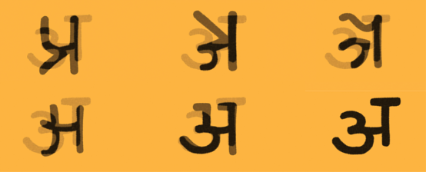

Screen Shots, Fontwala: Stone to mobile, what remains?

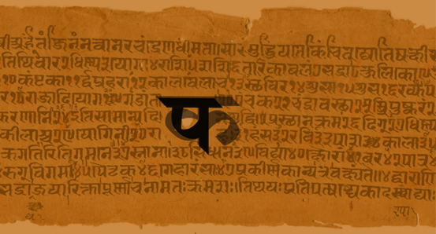

Akshar Mitra

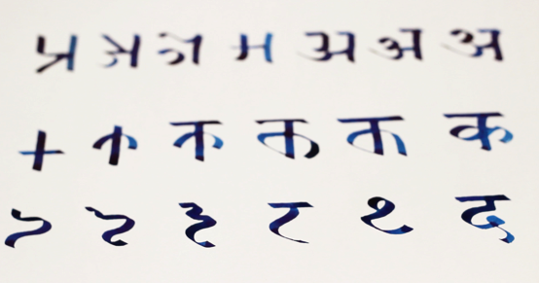From Brahimi to Devnagri

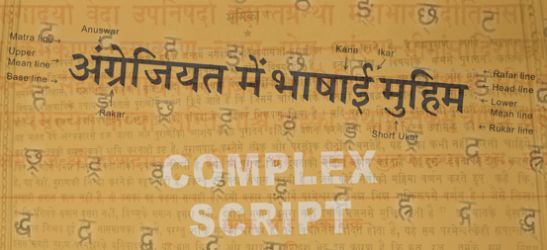
Complex Script

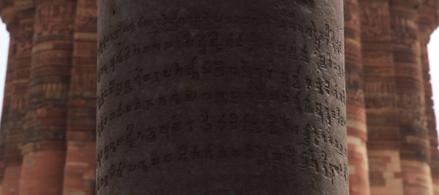
Iron Pillar

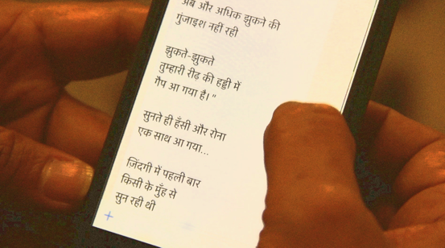
Mobile Hindi

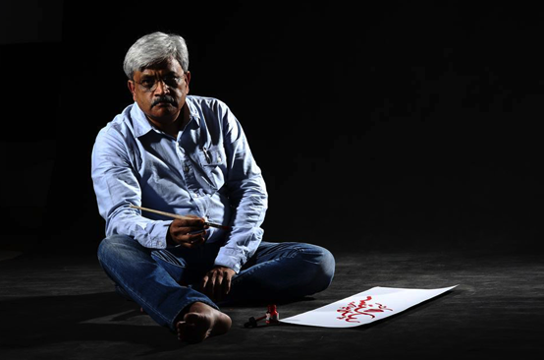
Fontwala Rajeev Prakash Khare

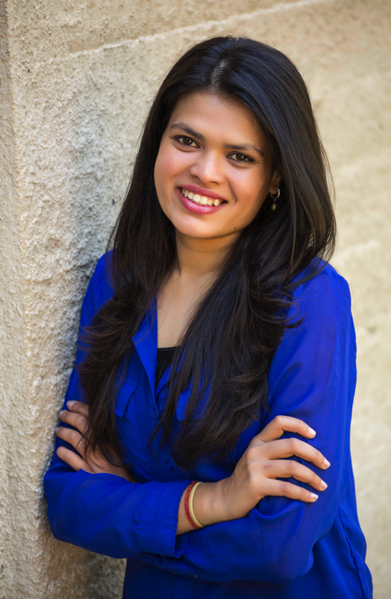
Shubhra Prakash.

